Maisqual projects/Ant Analysis

Background Information:

Ant is arguably one of the most relevant examples of a successful open source project: from 2000 to 2003, the project attracted more than 30 developers whose efforts contributed to nominations for awards and to its recognition as a reliable, extendable and well-supported build standard for both the industry and the open source community. An interesting aspect of the Ant project is the amount of information available on the lifespan of a project: from its early beginnings in 2000, activity had its climax around 2002-2003 and then decreased steadily. Although the project is actively maintained and still brings regular releases the list of new features is decreasing with the years. It is still hosted by the Apache Foundation, which is known to have a high interest in software product and process quality.

HO: The more the number of developers involved, the more bugs fixed and increase of number of commits.

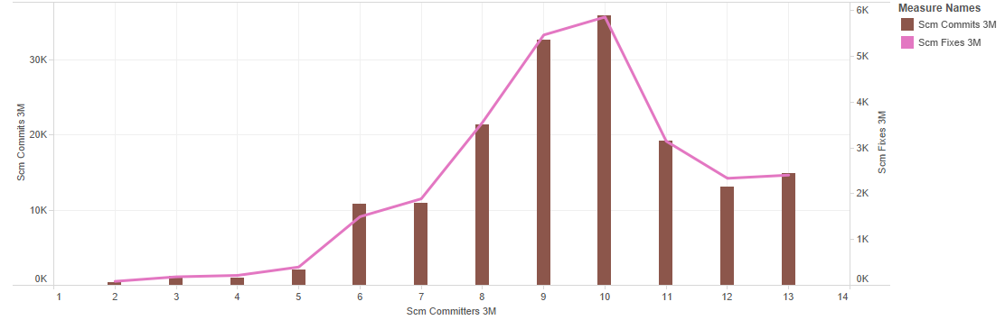What is the relationship between SCM_COMMITS_3M, SCM_COMMITTERS_3M & SCM_FIXES_3M?

This bar chart shows that as the committers increases, there is a strong tendency that commits increase also.

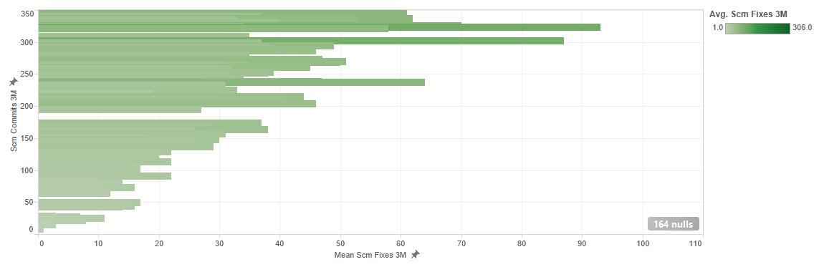What influences SCM_FIXES_3M?

Here we look at an overview of fixes and commits relationship. There is a predictive strength of 53% between these two variables. Each bar represents the fixes average at a level of commits. Levels with high or low fixes averages have more influences. Grouping the levels into high, medium, or low averages may reveal additional insights about the impact of commits on fixes over the last 3 months.

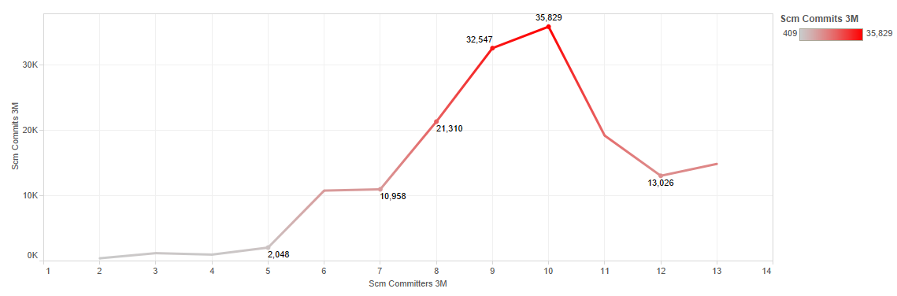How effective is the SCM_COMMITTERS_3M against SCM_COMMITS_3M & SCM_FIXES_3M?

This line graph shows that there is a significant strong main effect of committers and commits. Reason being, commits are being committed by committers/developers.

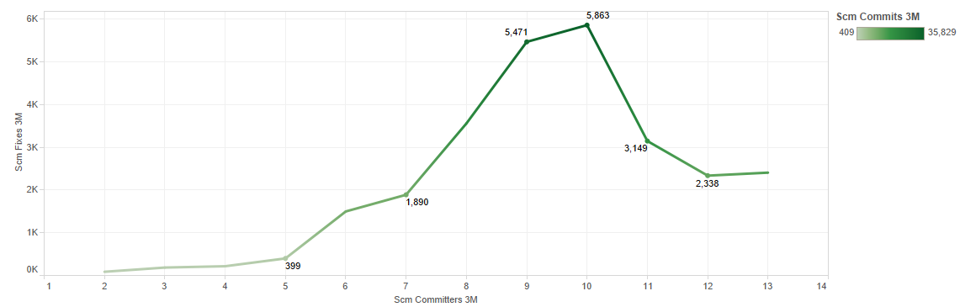This line graph shows that there is an increase tendency on committers and fixes over the last 3 months.

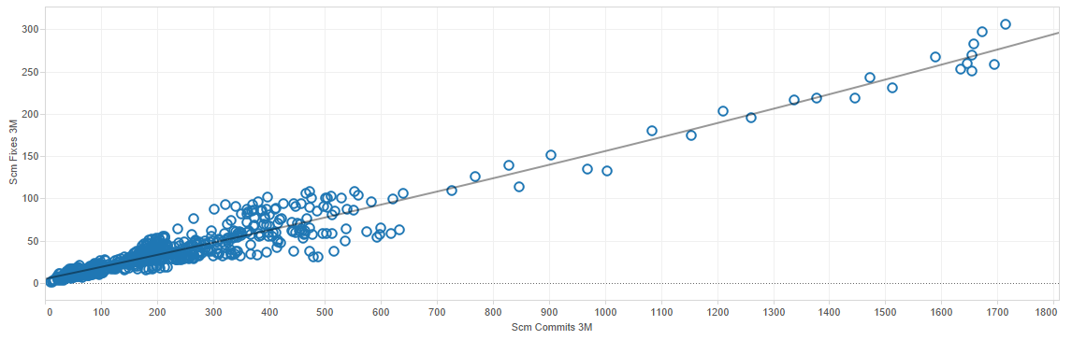Correlation between SCM_COMMITS_3M and SCM_FIXES_3M

The correlation between SCM_COMMITS_3M and SCM_FIXES_3M (r=0.96) is strong. As SCM_COMMITS_3M increases, there is a strong tendency for SCM_FIXES_3M to increase also. Therefore, SCM_COMMITS_3M and SCM_FIXES_3M are positively correlated proving the hypothesis statement to be true.

First I wanted to see,

H0: Does more source lines means there is more effective lines?

So I went to see the correlation of source lines and effective lines using tableau.

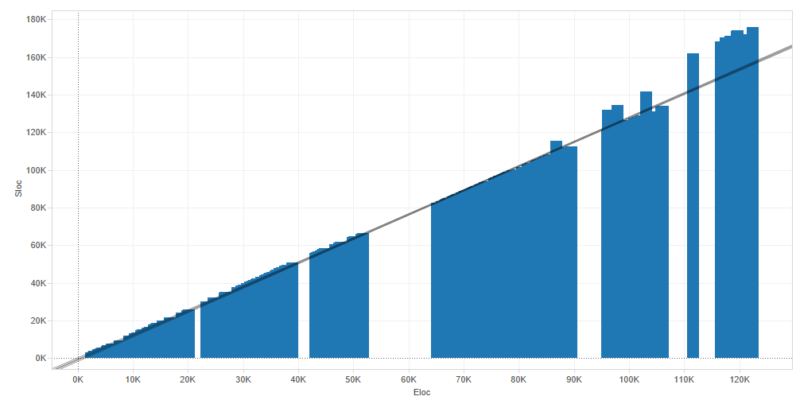

The graph shows that source lines and effective lines are very strongly related with the Pearson of 1. With that I find it not meaningful to continue H0. Thus I went on to see if there is other attributes related to effective lines, with a H1:

Effective communication leads to more effective lines.

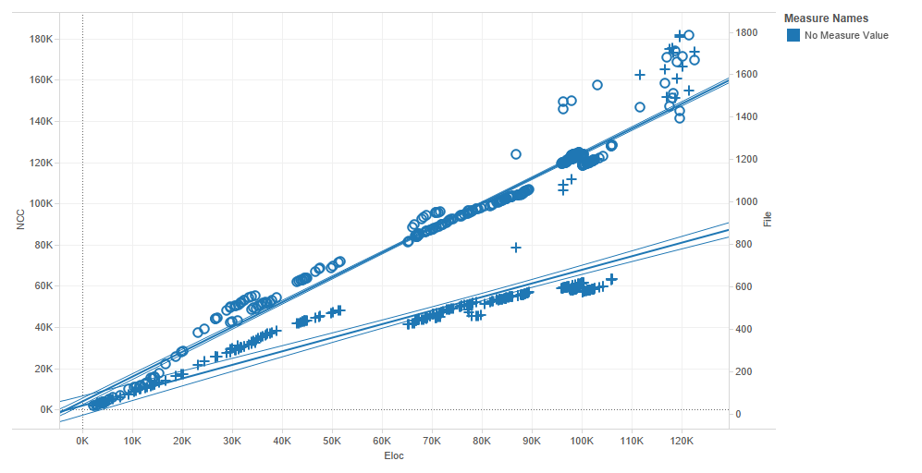

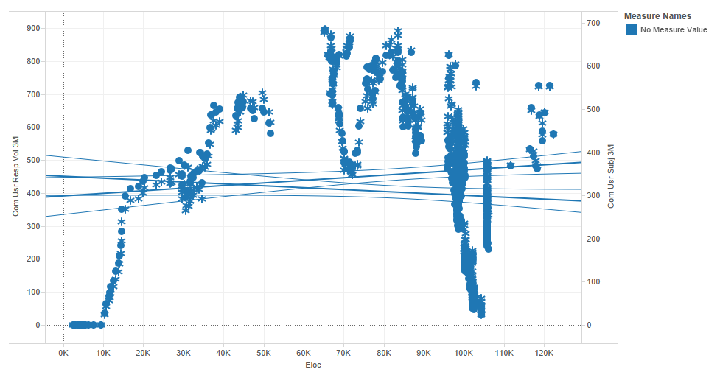

The relationship of the number of different subjects that have been posted on the mailing list in the last 3 months and the total number of replies to requests on the user mailing list in the last 3 months interest me. So I went to see how both attributes are related:

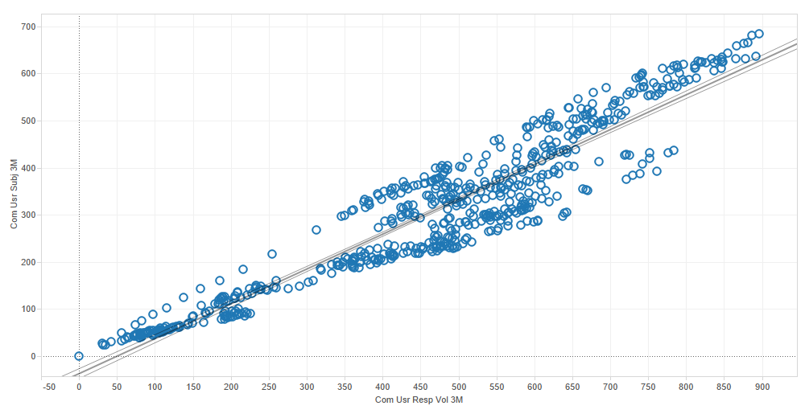

With the graph shown above, I came out with a conclusion that Effective communication leads to more effective lines.

Reference:

<http://maisqual.squoring.com/wiki/index.php/Maisqual_Projects/Ant>